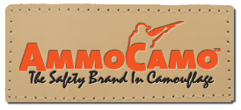
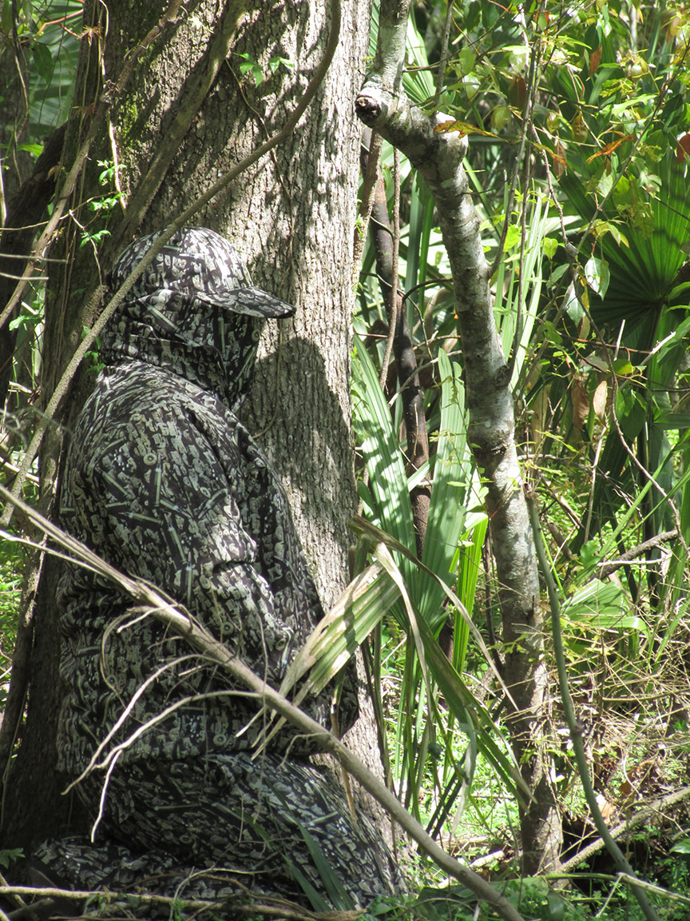
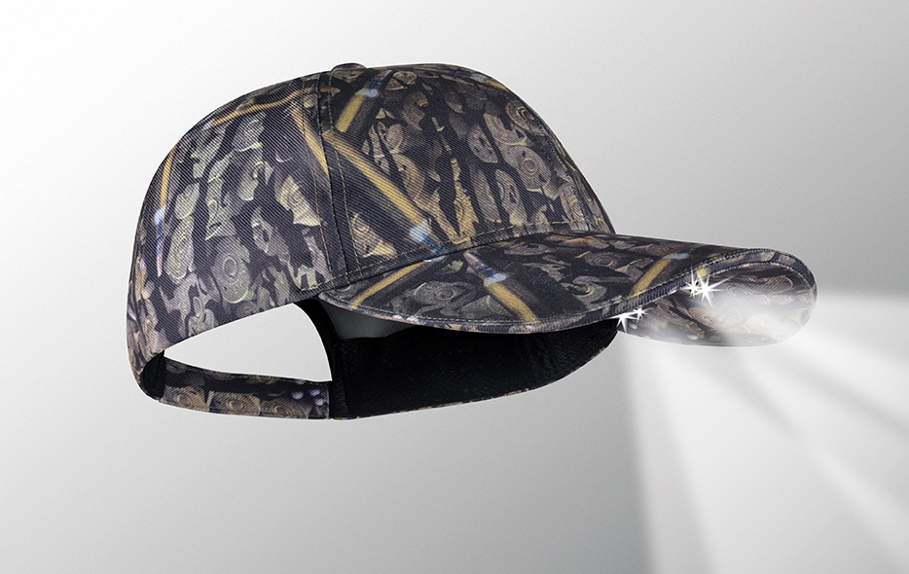
The story behind this brand is not just another cool camo pattern. This is about a gun safety initiative. The pattern combines golden brown images of ammunition combined with dark tree bark.
The seam tape inside of the caps is printed in blaze orange lettering “THINK SAFETY” in a repeat pattern. The founder of this line is Mr. Skip Leleux. Here is his story;

“The safety initiative of AmmoCamo™ is called Project ZERO, which is shooting for zero fatalities in all outdoor firearm activities. This is the most aggressive initiative ever in safety in the outdoors. The development of the AmmoCamo™ brand and patterns were actually born after the loss of my brother-in-law in an outdoor hunting
accident. My passion of wanting to provide a lifestyle in safety awareness for the outdoors is the driving force behind the brand.

Safety is not a fad.
It's not seasonal.
It's not market specific.

I developed the brand to touch every market in firearms. Whatever the activity: hunting, sporting clays, dog trials, concealed owners, safety instructors, second amendment groups, conservation groups and more. AmmoCamo is striving to gain that support from all walks of life and promote a true life style in safety awareness.

Safety will never go out of style. Last but not least, I didn't develop this to be the best functioning pattern to just hunt with. However, I welcome any challenge. BUT, my biggest desire is saving lives by being the Safety "Icon" in the outdoors that will remind someone to think twice and be more observant and better handle a firearm that will save a life. “

VISIT OUR WEBSITE WWW.PANTHERVISIONPROMO.COM
TO SEE THE FULL LINE OF LIGHTED PRODUCTS
OR CALL 847.783.5900 x 116 FOR MORE INFORMATION

Introducing the safety brand in camouflage to our POWERCAP® Lighted Headwear Line

AmmoCamo™

The “ultimate hands-free flashlight”, with high and low beam directional lights for distance and up-close tasks.

Easy on/off switch concealed under brim.

50+ hours continue battery life.

Because of the many uses, POWERCAP® delivers low cost per impressions for your customer

VISIT OUR WEBSITE WWW.PANTHERVISIONPROMO.COM
TO SEE THE FULL LINE OF LIGHTED PRODUCTS
OR CALL 847.783.5900 x 116 FOR MORE INFORMATION

VISIT OUR WEBSITE WWW.PANTHERVISIONPROMO.COM
TO SEE THE FULL LINE OF LIGHTED PRODUCTS
OR CALL 847.783.5900 x 116 FOR MORE INFORMATION

VISIT OUR WEBSITE WWW.PANTHERVISIONPROMO.COM
TO SEE THE FULL LINE OF LIGHTED PRODUCTS
OR CALL 847.783.5900 x 116 FOR MORE INFORMATION

VISIT OUR WEBSITE WWW.PANTHERVISIONPROMO.COM
TO SEE THE FULL LINE OF LIGHTED PRODUCTS
OR CALL 847.783.5900 x 116 FOR MORE INFORMATION

ASI 75825 SAGE 68668 PPAI 318255

VISIT OUR WEBSITE WWW.PANTHERVISIONPROMO.COM
TO SEE THE FULL LINE OF LIGHTED PRODUCTS
OR CALL 847.783.5900 x 116 FOR MORE INFORMATION

VISIT OUR WEBSITE WWW.PANTHERVISIONPROMO.COM
TO SEE THE FULL LINE OF LIGHTED PRODUCTS
OR CALL 847.783.5900 x 116 FOR MORE INFORMATION

Type your information here
POWERCAP® STEALTH 2575 MODEL PS4-199

